**BDM PROJECT**

**SUBMITTED BY –**

**SAGAR VASAIKAR (188009852)**

**TARANG HARIA (190004326)**

**SAGAR GUL ADVANI (188009815)**

**PART 1**

**Tables –**

Customer(Cust_id,Cust_name,Cust_age,Cust_ph,Cust_type,Cust_pref)

Guest(Cust_id,Guest_name)

Rooms(Room_id,Room_type,Floor,Amenities,Room_price)

Events(Events_id,Cust_id,Room_id,Event_name,Events_type,No_of_part)

Booking(Book_id,Cust_id,Room_id,Book_type,Book_desc,Date)

Payments(Pay_id,Cust_id,Book_id,Pay_amount,Pay_date,Pay_type)

**Assumptions and Constraints** **–**

Cust_id is UNIQUE,NOT NULL and PRIMARY KEY in the Customer table.

Cust_type can be primary or non-primary where the primary customers are responsible for the bill and non-primary customers are the dependents.

Cust_pref is the preference of the room type that the customer wants.

Cust_id in the guest table is the foreign key of Customer table which shows us who all dependents came along with the primary customer.

Room_id is the Room number which will be UNIQUE,NOT NULL and it is the PRIMARY KEY of the Rooms table.

Room_type can be single,double,king,queen,banquet or lawn.

Amenities can be spa,gym,parking,restaurant,room service,games lounge.

Room_price depends on the seasons and the discounts if there are any.

Events_id is UNIQUE,NOT NULL and it is the PRIMARY KEY of the Events table.

Events_type can be corporate,birthday,wedding,babyshower.

No_of_part depends on the event and how many people are attending.

Cust_id and Room_id are FOREIGN KEYS in the Events table.

Book_id is UNIQUE,NOT NULL and PRIMARY KEY of the Booking table.

Book_type is the mode of booking which can be on spot or online.

Book_desc can be additional notes mentioned by the Customer.

Cust_id and Room_id are the FOREIGN KEYS in the Booking table.

Pay_id is UNIQUE,NOT NULL and PRIMARY KEY of the Payments table.

Pay_type can be Debit,Credit or Online.

Cust_id and Book_id are the FOREIGN KEYS in the Payments table.

***ER DIAGRAM IS ATTACHED IN THE ZIP FILE.***

**PART 2 AND 3:**

**QUERIES FOR CREATING THE DATABASE AND SCREENSHOTS OF THE CREATED DATABASES:**

CREATE TABLE `sts`.`Customer`(

`Cust_id` int PRIMARY KEY NOT NULL,

`Cust_name` varchar(45),

`Cust_type` varchar(45),

`Cust_ph`varchar(10) CHECK (length(Cust_ph=10)),

`Cust_age` int,

`Cust_pref`varchar(45));

This is how our Customer page looks :

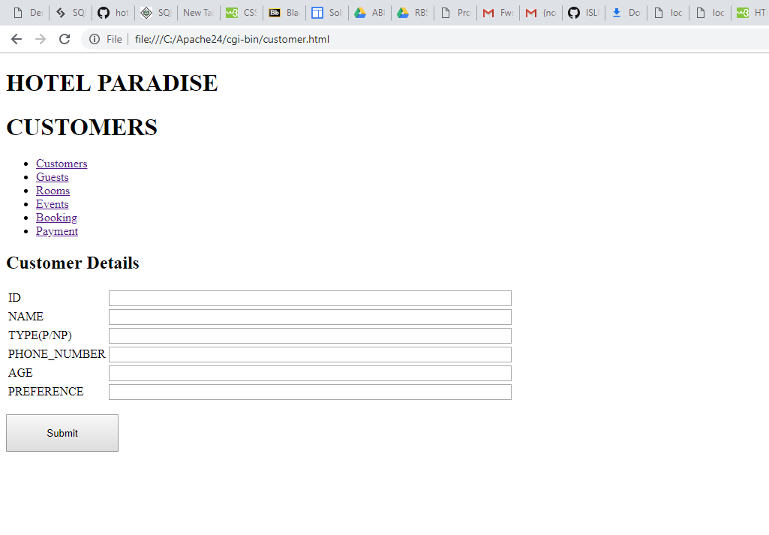

Below is the screenshot of our customer database created on browser:

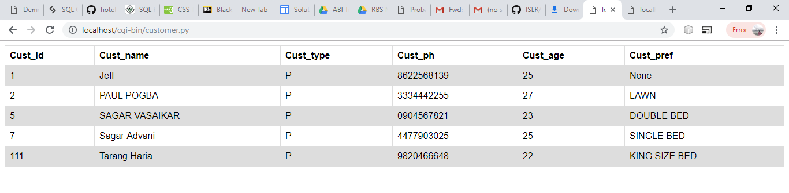

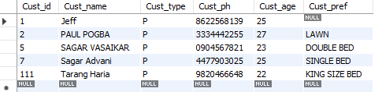

CREATE TABLE `sts`.`Guest`(

`Cust_id` int references Customer ,

`Guest_name` varchar(45) NOT NULL);

This is how our Guest page looks :

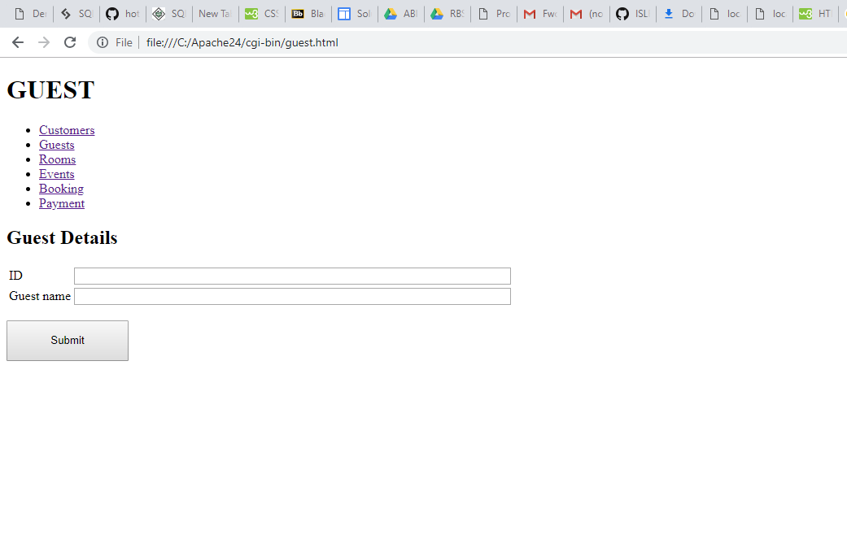

Below is the screenshot of our guest database created on browser:

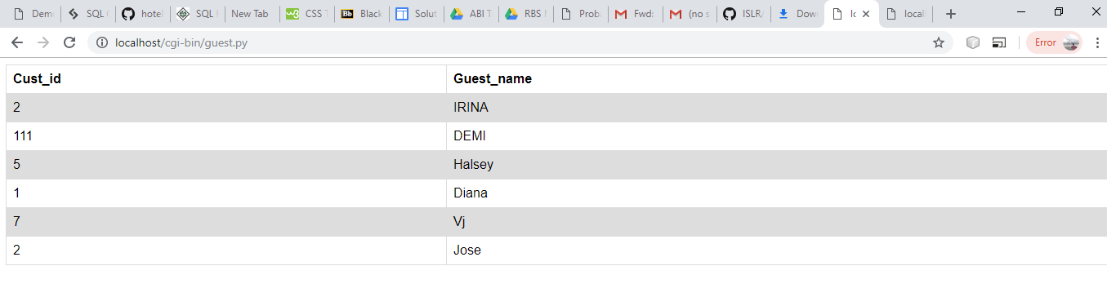

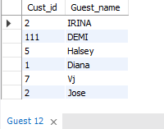

CREATE TABLE `sts`.`Rooms`(

`Floor` int,

`Room_id` int PRIMARY KEY UNIQUE NOT NULL,

`Room_price` int ,

`Room_type` varchar(45),

`Amenities` varchar(45));

This is how our Room page looks :

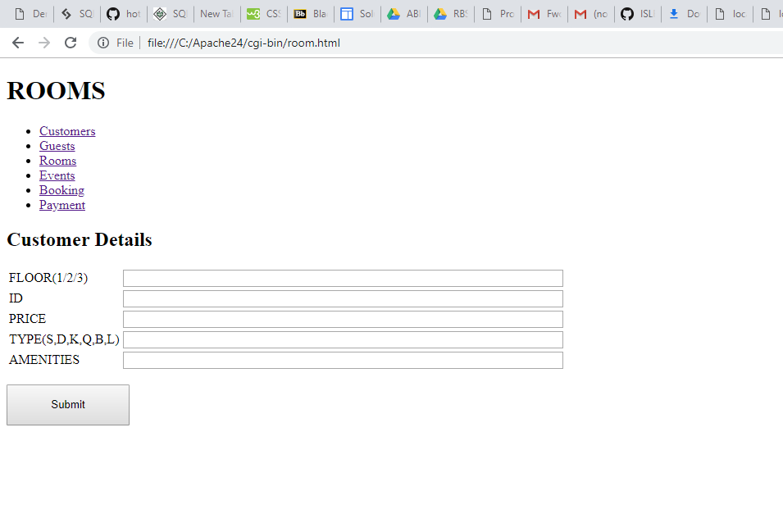

Below is the screenshot of our Room database created on browser:

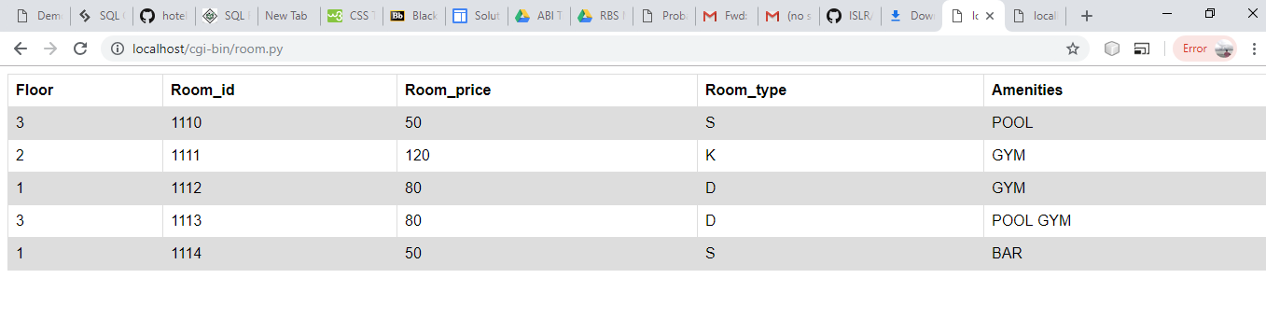

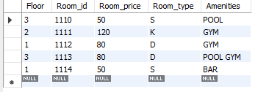

CREATE TABLE `sts`.`Events`(

`Event_type`varchar(45),

`Event_name`varchar(45),

`No_of_part`int,

`Event_id` int UNIQUE NOT NULL PRIMARY KEY ,

`Cust_id` int references Customer ,

`Room_id` int references Rooms);

This is how our Event page looks:

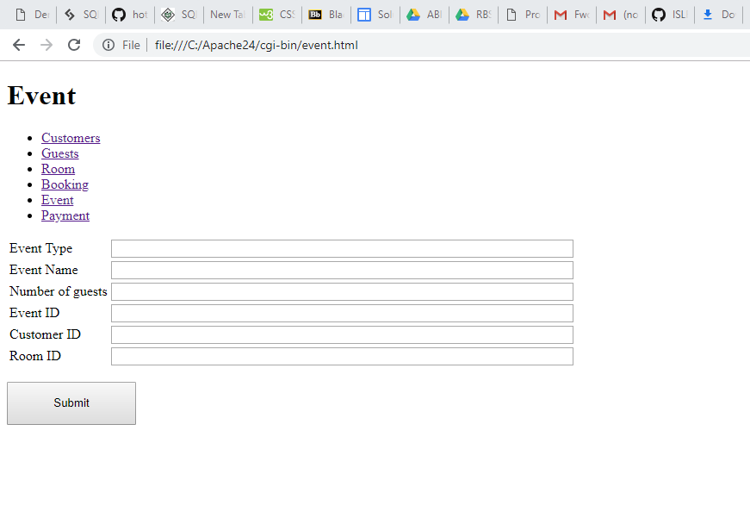

Below is the screenshot of our Event database created on browser:

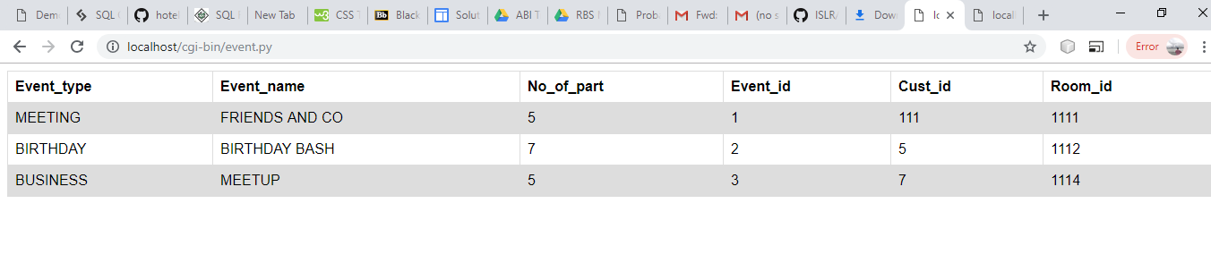

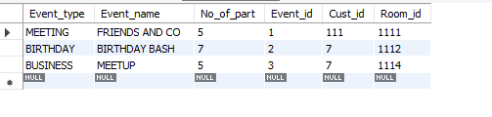

CREATE TABLE `sts`.`Booking`(

`Book_desc` varchar(45),

`Book_id` int Primary key not null,

`Book_type` varchar(45),

`Date` date,

`Cust_id` int references Customer,

`Room_id` int references Rooms);

This is how our Booking page looks :

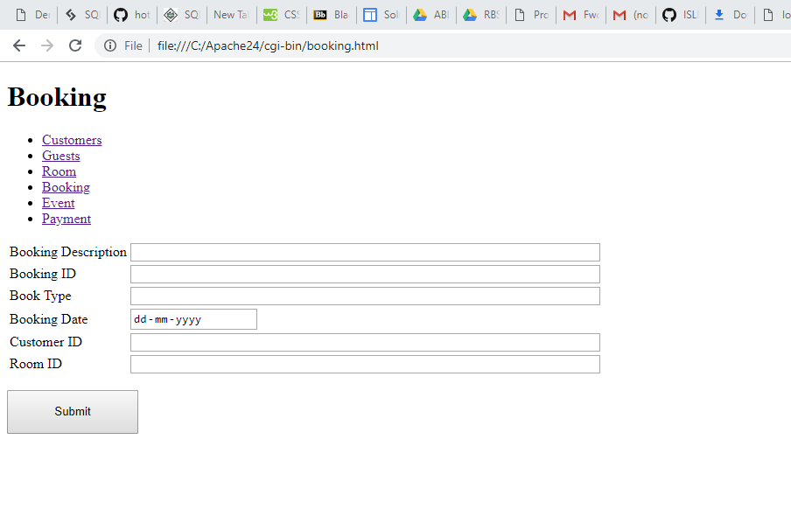

Below is the screenshot of our Booking database created on browser:

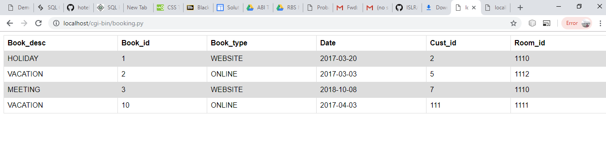

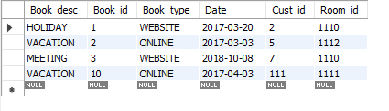

CREATE TABLE `sts`.`Payment`(

`Pay_type` varchar(45),

`Cust_id`int references Customer,

`Pay_amount`int,

`Pay_id` int primary key ,

`Pay_date` date,

`Book_id` int references Booking);

This is how our Payment page looks :

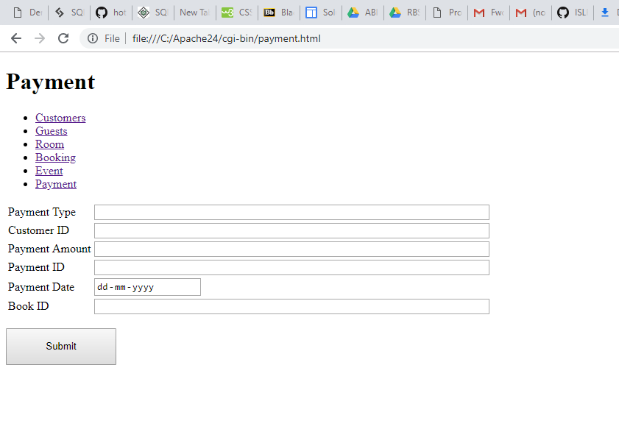

Below is the screenshot of our Payment database created on browser:

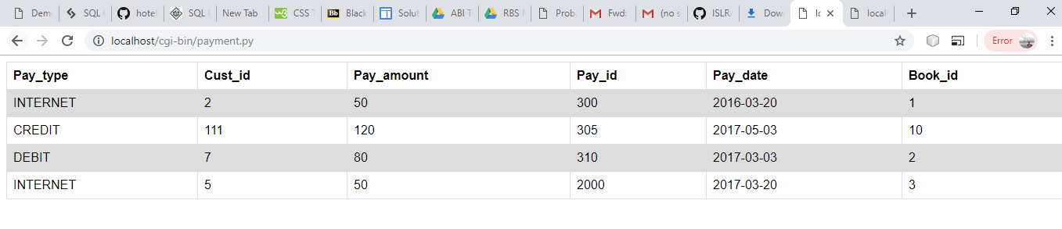

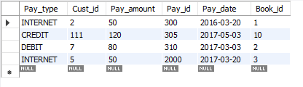

**Relational Algebra and Query –**

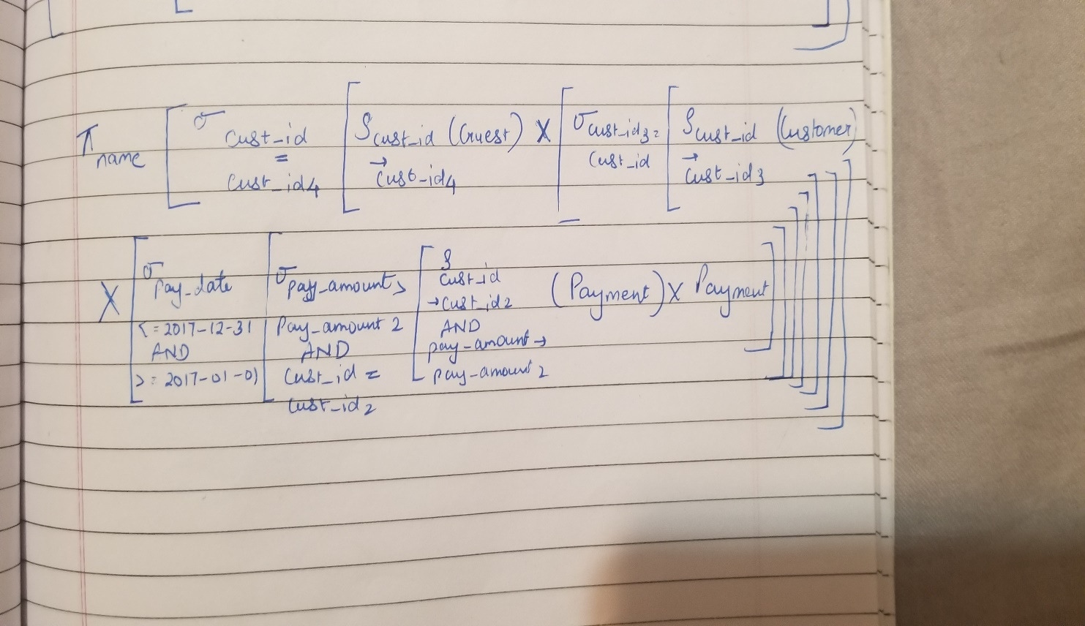

select distinct c.Cust_name from Customer c,Payment p,Guest g

where

p.Pay_amount in (select MAX(p2.Pay_amount) as MAX from Payment p2

where

p2.Pay_date between '2017-01-01' and '2017-12-31'

and

p.Cust_id = c.Cust_id)

and

g.Cust_id = c.Cust_id;

